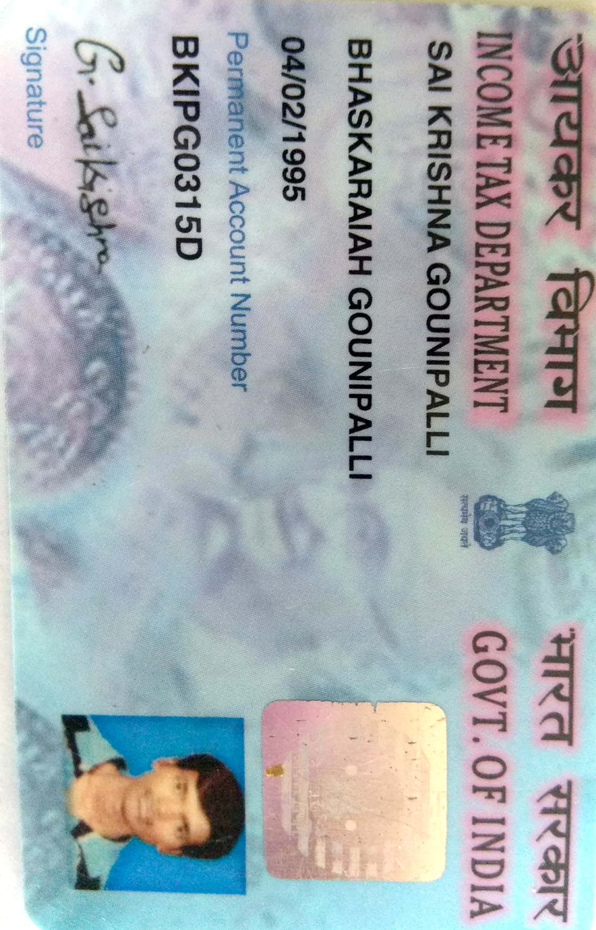

Candidate's Full Legal Name (as it appears on PAN)Vishal Nikam | Sai Krishna
Supplier Name (Registered Name) | People-prime Worlwide
Worked for CG previously? (IF yes share CG  Employee ID/GGID required | No
JOB Posting ID | CGEMJP00337007
Contact No (10 Digit No) | 6281493485
Email ID | saikrish1016@gmail.com
Job Location (Work Location) | Pune
Notice Period (Immediate/ Notice to Serve) | Immediate Joiner
Highest Education (Regular or Distance) | B. E
Employment Detail – Last 2 yrs Working period  (Payroll Company) | Ernst & Young (EY),
College & University Full Name - | JNTU Anantapur University
Mandatory Skills & Experience  (quick checklist – verify each skill, years of  experience) | Guidewire - 3.6Years
“Secondary” Skills & Experience | Gosu/JAVA– 3.6Years
Key Remarks (Supplier Comment) | Candidate Good at Communication Skill. He has relevant experience of 5.1 years.

SAI KRISHNA

Guidewire PolicyCenter Developer
Email: saikrish1016@gmail.com | Phone: +91 6281493485

PROFESSIONAL SUMMARY
I have technical Experience in Guidewire PolicyCenter Developer with 5.1 years of IT experience, including 3.6 years of specialized hands-on configuration. Expert in Gosu scripting, PCF/UI enhancement, and Data Model architecture within the Guidewire Cloud ecosystem. Proven track record of delivering high-quality enhancements for US and UK insurance leaders by optimizing underwriting workflows and system integrations.

TECHNICAL SKILLS
Platform: Guidewire PolicyCenter, Guidewire Cloud, Mammoth version.
Configuration: Entities, Typelists, PCF Screens, Dependent Dropdowns, Validations, Pop-ups, Coverages, Pre-Question Sets, Activity Patterns, Underwriter Rules, Forms.
Integration: Message Queues, Batch Processes.
Tools: TeamCity, Bitbucket.
Modules: PolicyCenter Configuration.

PROFESSIONAL EXPERIENCE
Software Engineer | Intenso tech solutions, Pune, India Dec 2023 –
Client: Ernst & Young (EY)
Present Project: Nationwide Insurance | Guidewire Developer
- Worked on Personal Auto and Homeowners lines of business in Guidewire PolicyCenter.
- Responsible for estimation, design, coding, unit testing, and deployment of enhancements.
- Configured Business Rules (BRs), Data Model updates, PCF changes, Batch Processes, Activity Patterns, Underwriting Issues, and Form Pattern changes.
- Configured and modified Coverages and Product Model using Product Designer.
- Configured Coverage Terms, Options, Deductibles, Conditions, and Question Sets in the Product Model.
- Implemented Eligibility Rules, Availability Rules, and referral logic for underwriting review.
- Customized Submission, Risk Analysis, UW Issue, and Policy Summary PCF screens.
- Configured and supported policy transaction pop-up messages for Submission, Policy Change, Renewal, Rewrite, Cancellation, and Reinstatement to guide users during transactions.
- Configured Forms, Form Patterns, and Form Filters for accurate policy document generation.
- Added and updated entities, typelists, and field-level configurations in the Data Model.
- Configured Activity Patterns based on task assigning to team or group or user.
- Implemented field-level validations, display logic, and dynamic UI behavior in PCF screens.
- Participated in sprint planning, requirement analysis, grooming sessions, and effort estimations.
Test Engineer | Smart Bytes Technology Services Apr 2023 – Nov 2023 Project: Aviva Insurance (UK) | Guidewire Developer
- Worked on Personal Auto and Homeowners lines of business in Guidewire PolicyCenter.
- Created new PCF screens, modifications, and UI designs.
- Worked on data tier components including custom and existing entities and typelists.
- Used Gosu scripting for development tasks.
- Created custom underwriting (UW) rules and modified existing ones.
- Configured Activity and Form Patterns to support policy creation.
- Involved in and monitored batch and scheduled batch processes.

- Configured coverages, limits, deductibles, and pre-question sets.
- Configured batch processes for scheduling.
- Created custom messages for asynchronous message queue integration with external systems.
- Used Guidewire Cloud API to extend existing APIs with additional fields.

Multi Skill Technician | Maverik Facility Management Pvt Ltd Sep 2020 – Feb 2022

EDUCATION

Bachelor of Engineering in Electrical and Electronics Engineering
JNTU Anantapur University | 2021

